APPLICATION FILE

2023-2024

ADVANCED MASTER® Defense and Security in Space
MS DefSiS

This file must be completed and sent by email with the required documents
before April 15th 2023, for the April admission session,
May 15th for the May admission session,
June 15th for the June admission session,

at:

admission-ms@ecole-air.fr

Application file

Complete all the items in this application file and join the required attachments which are compulsory

PERSONAL INFORMATION

Mr
Ms
Name
Given name
Date of birth
City of birth
Country of birth
Citizenship
Postal address
Postal code
City
Country
Mobile phone number
E-mail

EDUCATION

- Highest degree
Title of the degree
Year of graduation
Distinction or ranking
Optional subject
Name of the institution or university
Address of the institution or university
Telephone number
Internet site

- Other degrees (in chronological order)

Year | Title of the degree | Distinction or ranking | Name of the institution or university
 |  |  | Please note the precise postal code of the senior high school you attended:

- Level in aeronautics or space engineering or in digital technologies, in geopolitics, in defense and security studies or in business schools.

What is your level and what have you performed in these areas of expertise?

- Other possible training courses (note precisely the dates and results)

- Level in English

In order to prove their level in English, candidates must provide the results to the following tests:

Since the course is fully taught in English the required minimum linguistic level is B2 (European referencing system) upon presentation of a minimum score for one of the following exams: TOEFL (paper-based): 550, TOEFL (IBT) 79, TOEIC: 785, EILTS: 6.5, Cambridge, PLS 3333 (Standardized linguistic profile).

The following candidates are exempted from English tests:
-English speaking natives
-the candidates who do not speak French and who have studied or worked for at least two years in an English speaking university or country.

PROFESSIONAL CAREER

Years | Duration | Firm |  |  | Number of staff |  | Title or function
Years | Duration | Name | Place | Sector of activity | in the firm | In your team | Title or function

extra professional Activities

Financing the course

Individual
financed by the firm
financed by a funding agency
Name of the agency
grant
Name of the agency
Postal address
Tel E-mail

Applications for other programs

Are you applying for other programs? – Name(s) and place(s)

For which program(s)?

HOW DID YOU HEAR ABOUT AM DEFSIS?
French Air and Space Force website
Other websites Which ones
Media Alumni Career fairs
Orientation manual Others

INTEREST AND MOTIVATION
Describe and comment on your career plan

Date Signature

Documents to be attached
Tick the box and attach the relevant documents
1 Curriculum Vitae
1 cover letter
1 confidential letter of recommendation (professor, professional mentor, or past employer), submitted separately by the person recommending the applicant (see suggested form below)
1 passport photo
Copy of your identity card or passport
Copy of your highest diploma
Proof of English language skills (if required)
Application fee of 70 euros, to be paid either:
EXEMPTION FROM APPLICATION FEES FOR 2023 - 2024
by bank transfer to the account for which you will find the IBAN bank details below, taking care to specify the following information as a reference: name - first name - AM DefSiS
by cheque made out to the EAE school accountant
Initial primary control (IPC or CPR in French) : fil in all mandatory fields marked with an *. You must also fill in the field « previous address ». Do not fill in « 1 ». Please return to us as soon as possible. This document is intented for use in the context of a safety investigation.
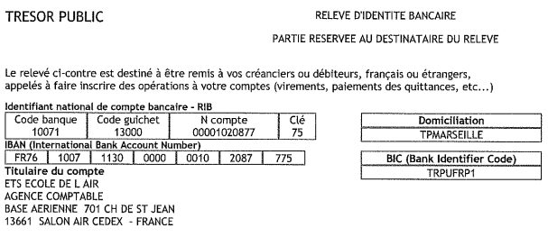

(Confidential)

Letter of recommendation (form)

NOTE FOR THE Referee

The person who has submitted this form is applying for admission to the Defense and Security in Space (AM DefSiS) Advanced Master® delivered by the French Air and Space Academy. We would be pleased to receive your feedback on this applicant.

After writing the letter of recommendation, please send it to our administrative services (Ecole de l'air et de l'espace depending on the status of the candidate), either by mail or by e-mail to:

École de l’air et de l’espace
DS/ Service scolarité
Chemin de Saint Jean
13661 SALON AIR

E-mail : admission-ms@ecole-air.fr

APPLICANT
Defense and Security in Space (AM DefSiS) Advanced Master ®
Family name
Given name

- How did you get to know the applicant?
- How would you characterize their strengths and weaknesses, skills and motivations?

- Indicate, as far as possible, what you think of the candidate on the following points:

 | Outstanding | Very good | Good | Average | Weak | No opinion
Intellectual abilities
Open-mindedness
Work capacity
Maturity
Interpersonal skills
Level of initiative

- How do you rate the potential of this candidate compared to students with equivalent backgrounds?

Well above average (in the top 10%)

Somewhat above average (in the top 30%)

Average

Below average

Name
Position
Name of the organisation or company
Mailing address

Tel

E-mail

Date Signature

